Creating a Procedural City

Joel Jurik
jurik@usc.edu
Chris Mangus
mangus@usc.edu
James Reinebold
reinebol@usc.edu
Samuel Woo
samuelcw@usc.edu

[insert picture of our city here]

Abstract
In this paper, we present a method of procedurally generating a 3D model of a city. Our approach fuses the continuous model synthesis algorithm with procedurally generated height maps. Continuous model synthesis is the process of generating a series of models with similar connectivity to a sample 3D polyhedral model used as a seed. Our algorithm successfully generates 3D models which can be used in a variety of applications.
CR Categories:
I.3.5 [Computer Graphics]: Computational Geometry and Object Modeling-;
Keywords: model synthesis, procedural modeling, height maps

Introduction
Creating realistic 3D models for use in the rendering pipeline is a well-known problem in computer graphics. A wide variety of applications, from computer games to movies require extensive 3D models.
Of particular interest is the construction of large-scale urban models. While building models in urban environments often resemble simple polyhedrons, even slight visual glitches can result in undesirable "uncanny valley" effects.
Traditionally, this problem has been solved through the use of teams of artists. Models constructed by artists are often visually pleasing. Unfortunately, such a solution takes extensive resources. The artists working on Superman Returns, for example, took over 15 man-years to construct the urban models of Metropolis [Merrell 2009].
While cityscapes in some films require 1-1 correspondence to actual buildings (such as modeling the Empire State Building in a film set in New York City), often computer games and movies do not require such realism as long as the general feel of a city can be maintained. For example, the Valve PC game Half-Life 2 takes place in the fictional City 17 and Superman Returns takes place in fictional Metropolis. Only maintaining the feel of a city is necessary to maintain the user experience in media such as these.
It is in these environment that the approach described in this paper can save vast amounts of time and effort.

Related Work
There are a variety of techniques which can generate realistic 3D models of cities.
One approach has been to use aerial LiDAR information from real cities to replicate the actual 3D height information [Zhou 2010]. While this approach produces highly detailed models, it also requires existing LiDAR data. In addition, it cannot be used to generate a fictional city that bears little resemblance to existing cities.
The continuous model synthesis algorithm proposed by Merrell [2007] represents a different way to approach the problem of urban model generation. Continuous model synthesis draws on a long history of advances made in procedural texturing to create three-dimensional models.
A procedural texture is a texture generated by a function as opposed to an artist. Functions can easily be designed to approximate marble, fire, wood, or clouds [Perlin 1985].
The rest of this paper will review of the approach described in Merrell 2007 and discuss on how it can be extended to generate more realistic looking cities through the use of custom height maps.

Continuous Model Synthesis

Algorithm Overview
The input for continuous model synthesis is a polyhedral model defined by the user. The normal of each face of the model is calculated. Then, the algorithm draws a set of parallel planes with this normal. These planes are spaced apart by a user defined distance and constrained by a bounding volume. Intersections between three planes forms a vertex. The collection of vertices formed from the intersections of planes forms the set from which vertices in the final output model can be chosen. However, only vertices which satisfy the adjacency constraint, as explained below, are allowed to be present in the final model.
Vertices satisfy the adjacency constraint if and only if the connectivity of that vertex is equivalent to the connectivity of the corresponding vertex on the input model.
We will now go into more detail on the algorithm as a whole in both the 2D and 3D cases.

The 2D Case
Continuous model synthesis is possible to implement in 2D. For our project, we decided to first attempt the algorithm in 2D and then expand on our 2D results for the full procedural city.
The user provides a polygon as input by specifying a set of vertices connected by edges. Sets of parallel lines are drawn corresponding to each of the input edges. Vertices are formed corresponding to where the different sets of lines intersect.
A vertex can either be present in the final output shape or it can be absent. A present vertex can either be part of the boundary of the shape or it can lie entirely inside the interior of the output shape.
Continuous model synthesis allows any vertex to be either fully inside or fully outside the output shape. However, a vertex can only be on the boundary of the shape if it has the same connectivity as it did in the input model as shown in Figure X.
[Probably want to clarify this with a 2D drawing showing the states similar to the Merrell paper]
The pseudocode for the entire 2D algorithm is as follows:
Grid = []
States = []
Model = []
For each edge in shape:
Add a set of parallel lines to the grid
For each intersection point v in grid:
states += all valid states of v
while states is not empty:
S = random state in states
Add S to Model
Remove all states conflicting with S from states
Remove S from states

An example of the output shapes generated by the 2D case is shown in Figure 1. As only states with consistent connectivity are allowed, either only the polygon enclosing the green dot, all polygons surrounding the red vertex, or none of the polygons surrounding the red vertex are allowed.

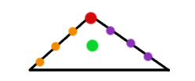
Figure 1: A sample 2D shape for continuous model synthesis.

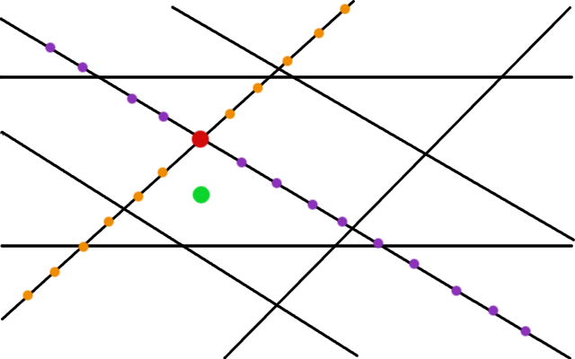
Figure 2: A sample grid constructed in 2D by continuous model synthesis.

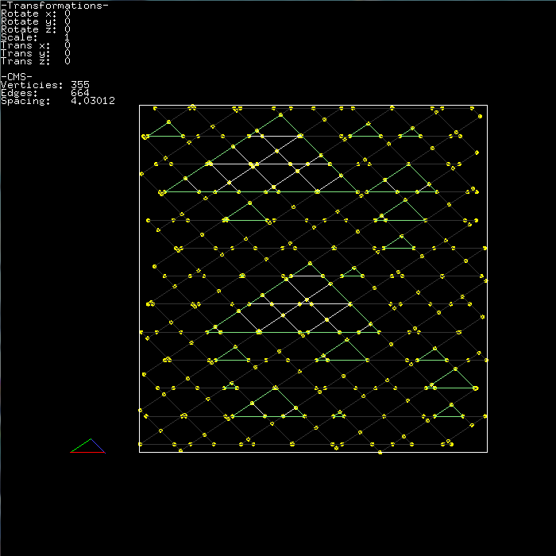
Figure 1(a): The 2D grid. The shapes generated by the algorithm are not necessarily connected, but have a similar structure to the polygonal model supplied as input (in this case a triangle, shown in the bottom left of the image).

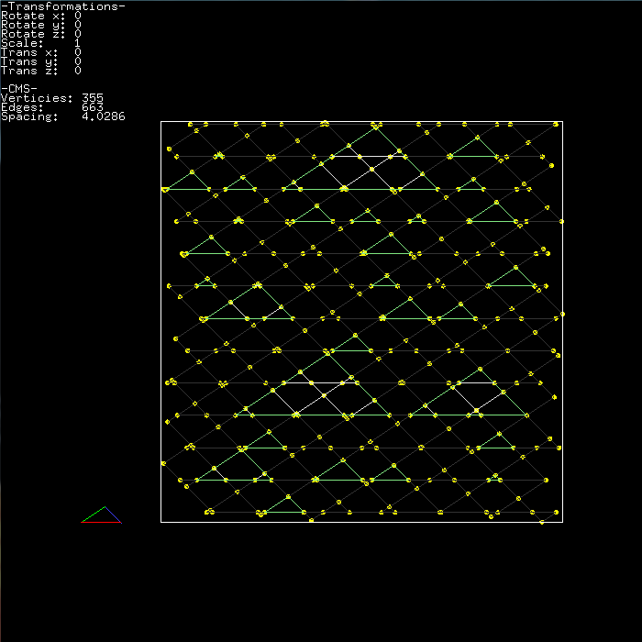
Figure 1(b): A second case of a 2D grid. Notice that although similar substructures occur between Figure 1(a) and Figure 1(b), the shapes generated by the algorithm are distinct.

The 3D Case
The 3D case for continuous model synthesis is similar to the 2D case in many ways. Instead of drawing lines parallel edges of the input model, instead form sets of parallel planes having the same normal as the faces of the input model. An example of such a construction of parallel planes can be seen in Figure 2. Whenever three planes intersect they form a vertex, as shown by the grid in Figure 3.
Once the grid has been constructed, examine each vertex in the list of vertices. A vertex is either part of the output model or it is not part of the output model. Any vertex which is part of the output model either lies in the interior of the volume or is on one of the exterior faces of the polyhedron.
Vertices on the exterior faces of the polyhedron must have a similar connectivity to the corresponding vertex on the input model as shown in Figure X.
Several of the geometric calculations necessary for the 3D case are not intuitively obvious. Three planes intersect in 3D space whenever X [CITATION NEEDED].
As some of the planes intersect the bounding box, an additional check is necessary to see if the six faces of the bounding box intersect with any of the planes. This check can be made by splitting the face of the bounding box into four edges and finding the plane line intersections. The two edges which have a valid intersection form the edge of the grid which is a part of the bounding box [CITATION NEEDED].
The pseudocode for the entire 3D algorithm is as follows:
Grid = []
States = []
Model = []
For each face in the input:
Add a set of planes parallel to face to grid
For each intersection point v in grid:
states += all valid states of v
while states is not empty:
S = random state in states
Add S to Model
Remove all states conflicting with S from states
Remove S from states

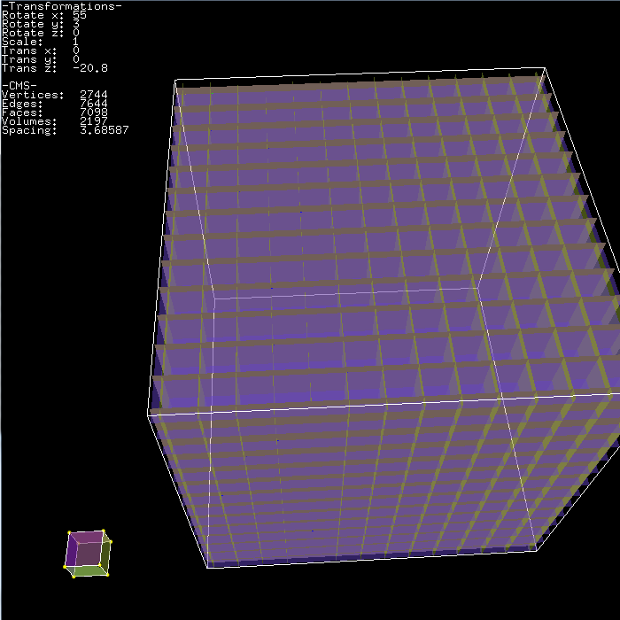
Figure 2: The set of planes generated from the input model in the 3D case. The input model was a cube shown in the bottom left of the image.

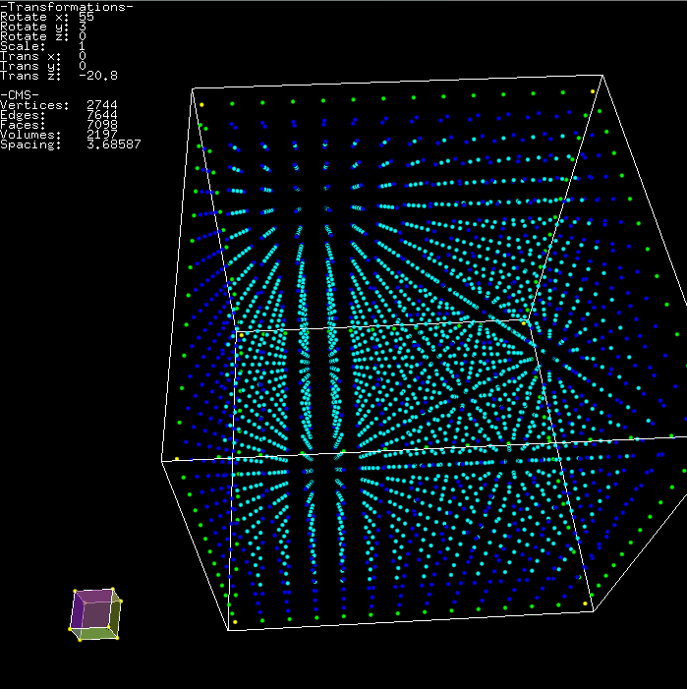
Figure 3: The set of vertices generated by the intersections of the planes taken from the faces of the input model.

3.4 Implementation Details
Talk about what we did to implement the algorithm here.
We chose the open source rendering engine FreeGLUT as our basic rendering pipeline for this project. FreeGLUT natively supports the basic OpenGL functions.
All coding was done using Microsoft Visual Studio 2008 in C++. We used the Standard Template Libraries to implement the complex data structures used in determining edge states.
The bounding volume we used for our project was a cube, but this need not be the case in continuous model synthesis. Our choice of a cube was done for simplicity.

4. Extending the Algorithm with Height Maps
[Talk about height maps in general]

5. Results
[Insert screenshots here of all of our results. We probably want this to take up 1-1.5 pages]

6. Unexpected Problems
While Merrell describes the algorithm as "simple to implement", the reality is somewhat different. Generating a list of possible states requires very complicated data structures. Each of the edges generated by finding the intersection of the planes from the original model needs a reference to vertices formed from the intersection. In addition, each of the subvolumes formed by segmenting the bounding volume of the city needs to have references to each of the edges and the vertices. Keeping track of these references and data structures in order to carry out the continuous model synthesis algorithm is arduous and requires great care while coding.

7. Conclusion
We have presented a set of algorithms to generate procedural cities. Although more complicated than described in the initial paper, it worked satisfactorily to generate a complex 3D urban model which was substantially different than the initial sample model provided to it.
The 3D models produced by our set of algorithms could be used in a variety of applications from games to movies and save many man-hours of modeling work.
8. Acknowledgements
We would like to thank the open source developers of the FreeGLUT project for their implementation of OpenGL. In addition, we would like to thank the content management system GitHub which enabled our group to collaborate for the programming portion of this assignment.

References
[1] Merrell, P. and Manocha, D. 2008. Continuous model synthesis. ACM Trans. Graph. 27, 5 (Dec. 2008), 1-7. DOI=
[2] Merrell, Paul C. 2009. Model Synthesis. Doctoral Thesis. University of North Carolina at Chapel Hill.
[3] Perlin, Ken. 1985. An Image Synthesizer. SIGGRAPH Comput. Graph. 19, 3 (July 1985), 287-296. DOI=10.1145/325165.325247 http://doi.acm.org/10.1145/325165.325247
[4] Teoh, S. 2008. Algorithms for the Automatic Generation of Urban Streets and Buildings. In Proceedings of the International Conference on Computer Graphics and Virtual Reality, July 2008.
[5] Q. Zhou and U. Neumann. "2.5D Dual Contouring: A Robust Approach to Creating Building Models from Aerial LiDAR Point Clouds." In Proceedings of 11th European Conference on Computer Vision (ECCV). September 5-11, 2010 (Oral Paper).

